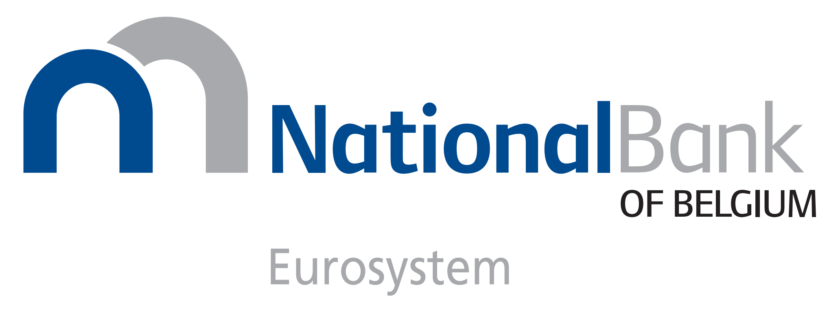

DECLARATION OF AGREEMENT WITH THE
“NATIONAL BANK OF BELGIUM - TERMS AND CONDITIONS OF TARGET-BE”

The undersigned:

(Company name) ……………………………………………………………………

With BIC11 ……………………………………………………………………

Having its registered office at: ……………………………………………………………………

duly represented by ……………………………………………………………………

hereby declares to agree that the legal relationship between it, as participant in TARGET-BE, and the National Bank of Belgium (“NBB”) shall be governed by the Terms and Conditions of TARGET-BE and their Annexes, as these documents are published on the NBB’s website (www.nbb.be) on 20 March 2023 and amended from time to time.

Done at …………………………………….., on………………………..

Name: …………………………………………….…..

Title: …………………………………………….…..

Signature: …………………………………………….…..

