boulevard de Berlaimont 14 – 1000 Brussels
Phone: +32 2 221 38 12
Company number: 0203.201.340
RPM (Trade Register) Brussels
www.nbb.be
Public
Brussels, 27 June 2023
Annex 2 to Circular NBB_2023_07
Reporting tables 90.30.a, 90.30.b and 90.30.c

Reporting table 90.30.a

 |  | Economic value  Banking Book | Interest result |  | Market Value of Instruments Measured at Fair Value
 |  |  | Actual | Expected
 |  |  | Previous 12 months | Next 12 months
 | CODE | 010 | 020 | 030 | 060
1. Steeper yield curve | 100
2. Increase in short-term interest rates | 200
3. Parallel increase in interest rates with 200 basis points | 300
4. No movement | 400
5. Parallel decrease in interest rates with 200 basis points | 500
6. Decrease in short-term interest rates | 600
7. Flatter yield curve | 700

Reporting table 90.30.b

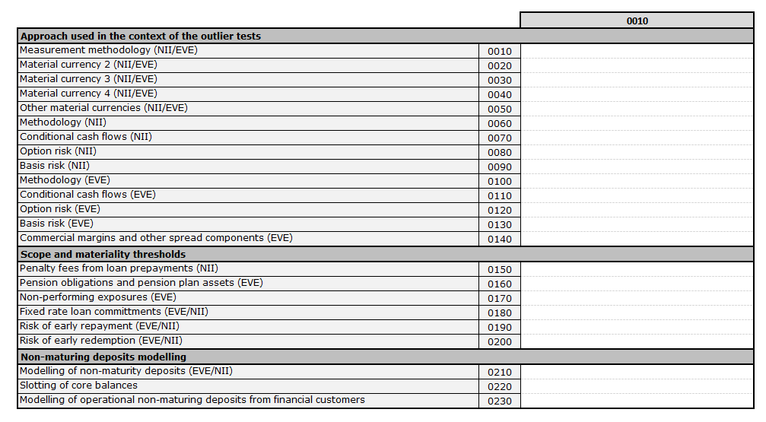

Reporting table 90.30.c

